PCVIPR Flow Tool Instructions

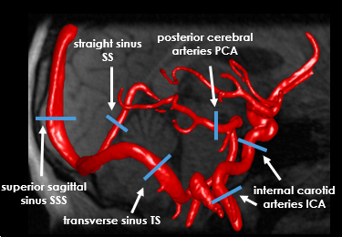

Last updated: June 22, 2021

# Revision History

* June 22, 2021: Original document compiled (Leo)
* August 18, 2022: Change repository to ‘uwmri’ and added more measurement locations (Grant)
* Please document any updates you make here!

Table of Contents

Revision History 2

1.0 Flow data. 4

2.0 Flow Tool 5

2.1 Installation 6

2.2 Operation 6

# 1.0 Flow data

PCVIPR flow data is typically written in one of two formats:

1. Binary and text files (old format, lot of files)

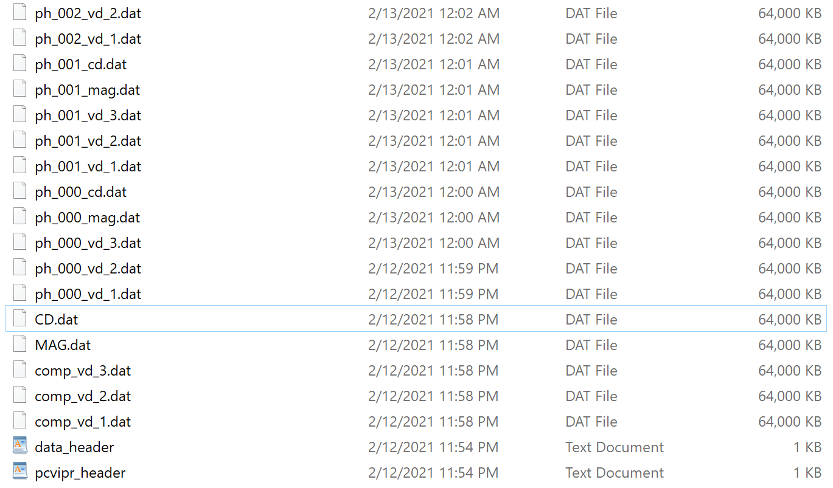

1. HDF5 file (single file)



Either format is readable by the flow tool and the data should be the same. If you are using format 1. (dat files) make sure the pcvipr_header.txt (required to run tool) is in the same directory your data is store and gating files are copied to the directory where you will save your data to in order to output cardiac gating statistics during the flow analysis. Below are two examples of gating files (notice ends in .pcvipr_track).





There are older files called ecg_track, but the current flow tool does not supporting them. If gating information from an Gating_Track or ecg_track is needed, just run the importGating.m. Finally, 2. (.h5 files) have all the header and gating stats info contained.

# 2.0 Flow Tool

# 2.1 Tool Installation

1. Download Flow tool repo located in here:

<https://github.com/uwmri/QVT.git>

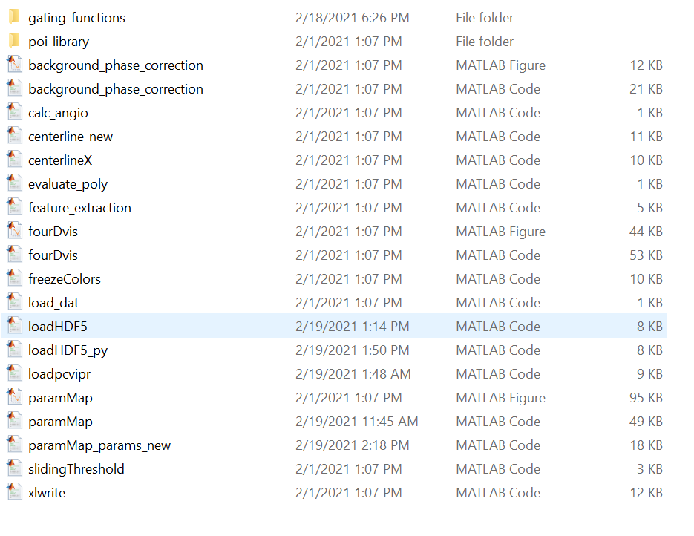

2. Add the flow tool repository to your matlab path.

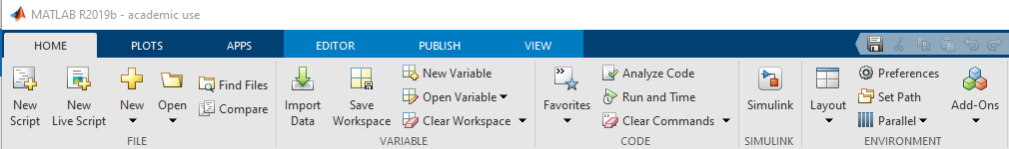

# 2.2 Operation

1. In matlab command line start the tool by typing:

paramMap

2. This will launch the GUI

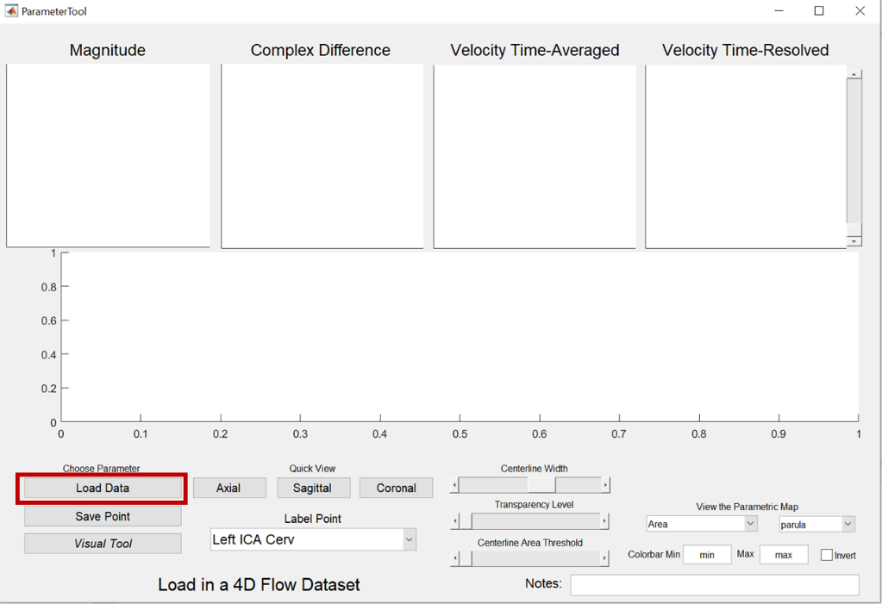

Then you can start loading the data (.dat or .h5 files). You don’t need to write in the same dir where your data is located (more on that further down). If this is the first time you work on the case you will select load new case option:

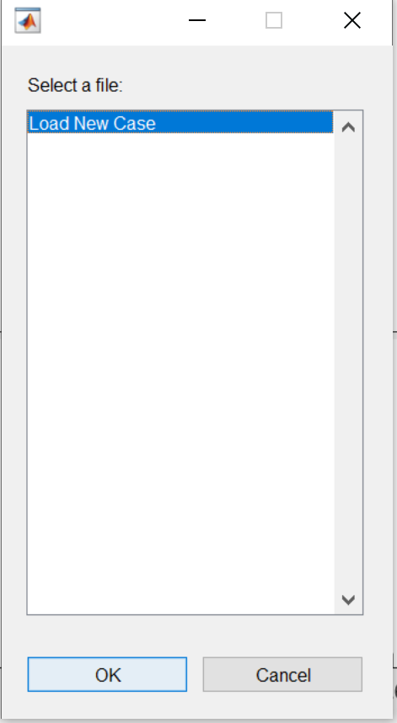

If you already worked on the case, you can just load the saved .mat and quickly access the segmented vessels for additional measurements.

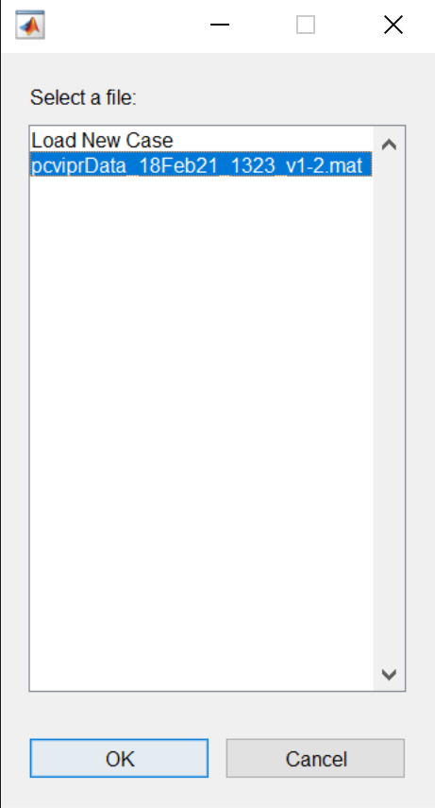

3. If you load a new case, the next prompt will ask you to perform background field corrections by fitting a polynomial to the tissue phase. In most cases, automatic phase background correction should be performed. You will see the window shown below. If phase correction is correctly applied, static tissues will be solid orange, while vessels, csf spaces, and air will not be highlighted. Adjust the CD and noise sliders until all static anatomy is solid orange and vessels, air, and csf spaces are not highlighted. This is what is used to fit the background phase for removal. Most of the times the default settings are sufficient! (don’t waste time here).

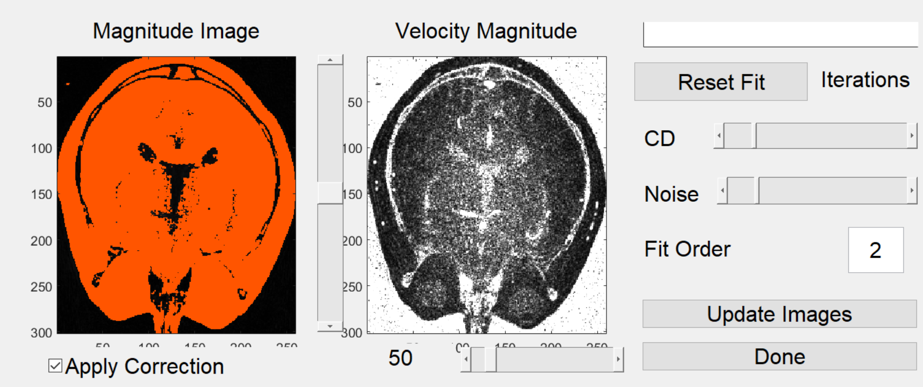

Click ‘Update Images’ and the background phase correction will be applied to all of the data.

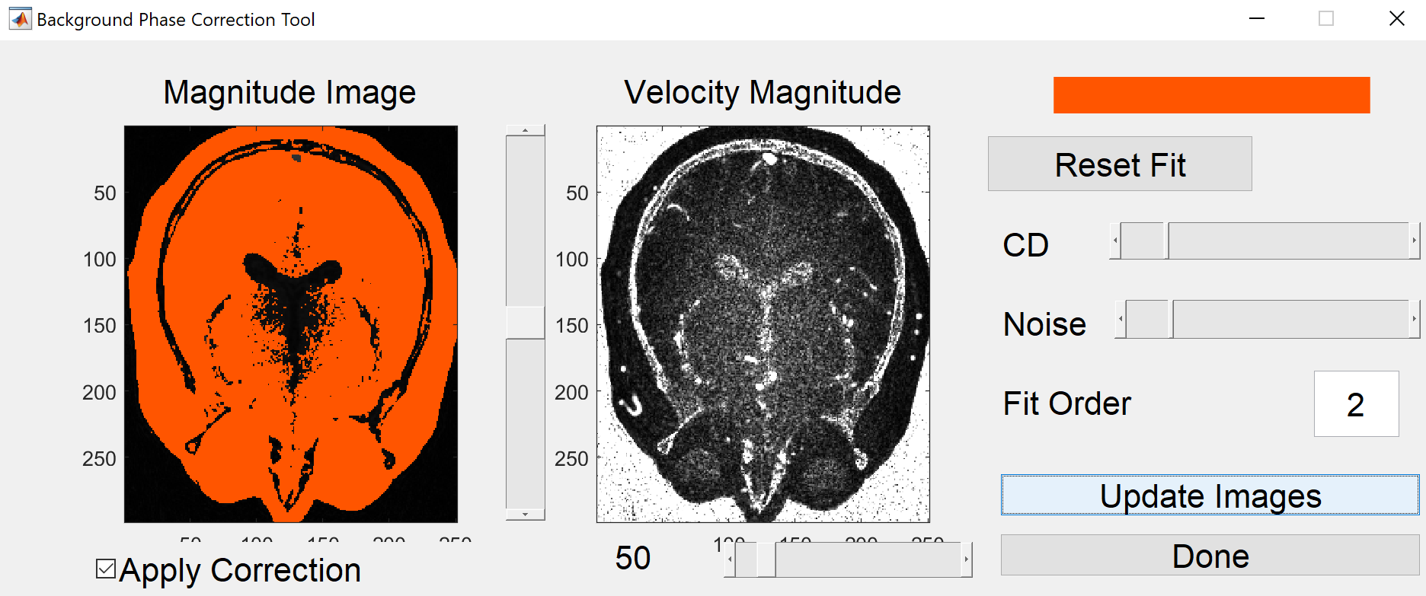

Once finished click ‘Done’ (be careful, do not Update Images twice!!!).

The GUI will then ask you where you want to save your data analysis and it will generate a .mat file with the vessel segmentation data amongst other files:

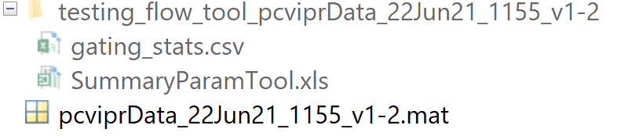

gating_stats contains heart rate information

* Make sure HR makes sense! E.g. < 120bpm and likely > 39bpm
* Make sure Value within expected RR (%) are > 80%
* If these two conditions are not met, **you should not use the *Pulsatility index*** results since they will likely be wrong.

SummaryParamTool.xls will contain measures of mean flow, and pulsatility index extracted from the vessels.

Now we are ready to extract measurements using the tool:

We will be using the following two windows:

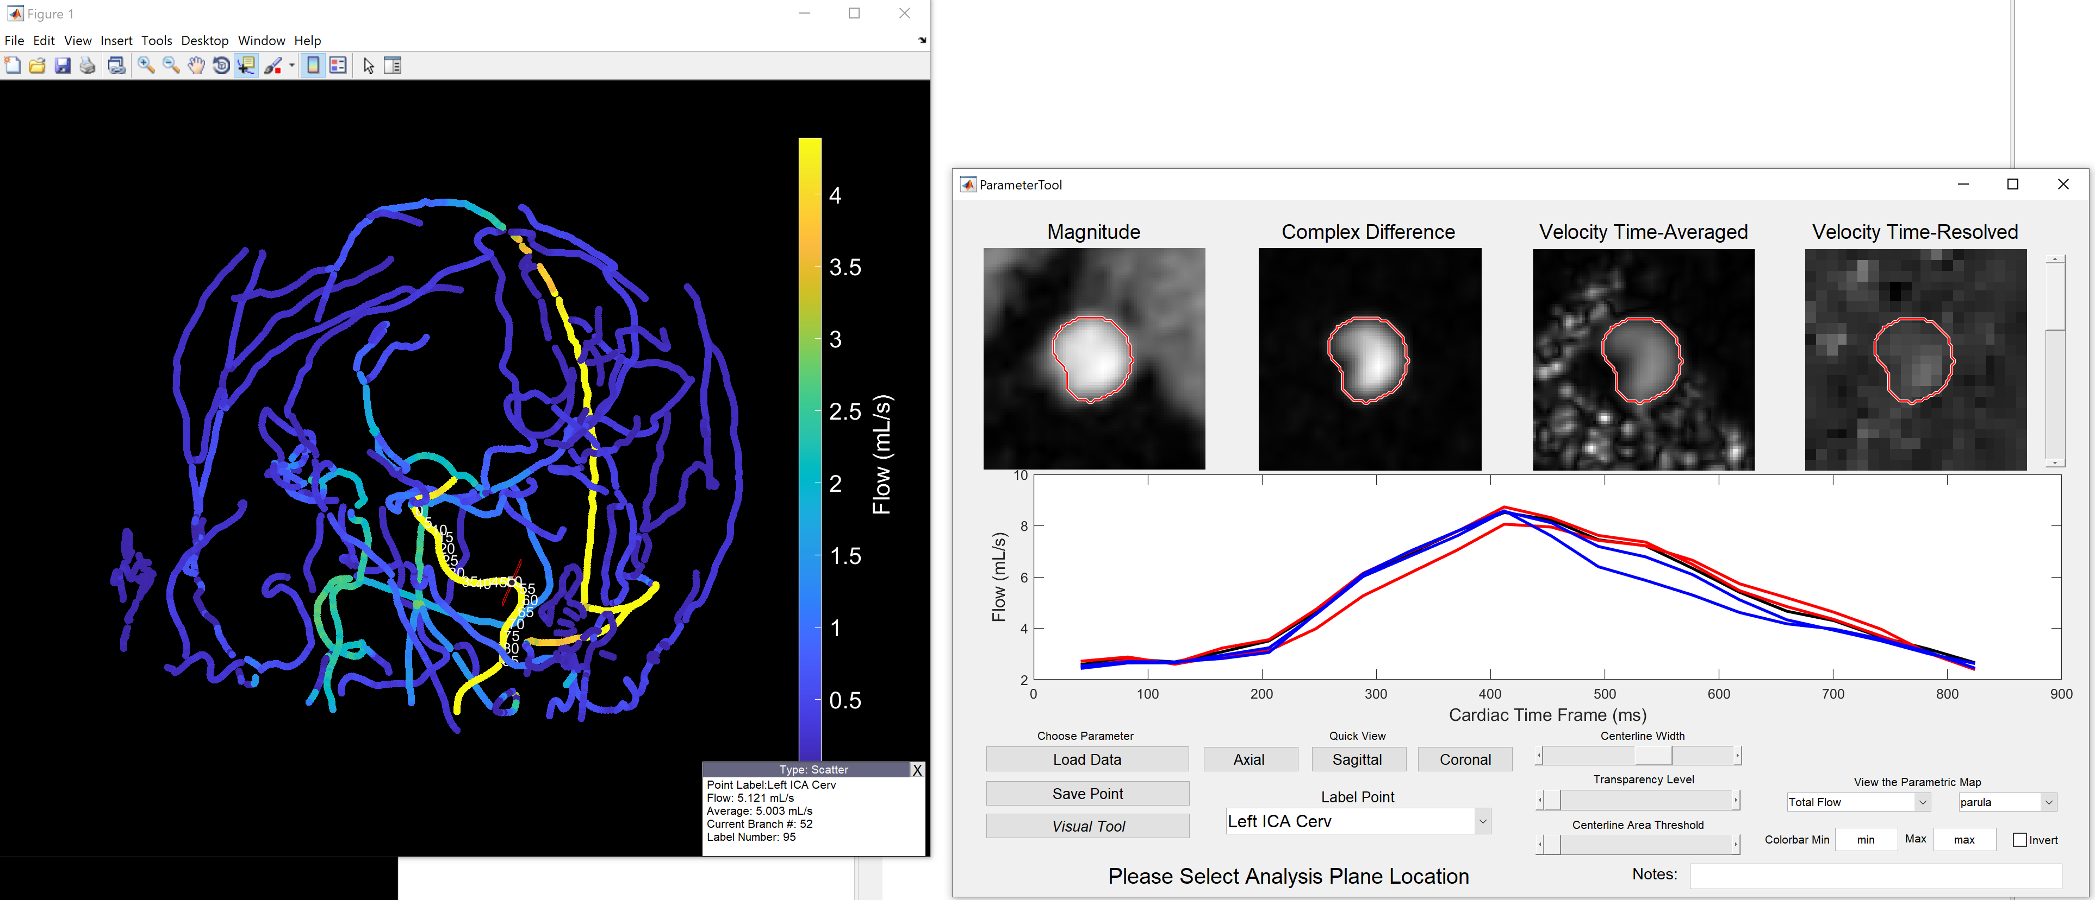

Segmented angiogram (left) and main GUI (right) (don’t change window size of main GUI (bug))

On the left is the “skeleton” of the vessels which you will use to navigate to the desire landmark.

Make yourself familiar with the options to zoom, drag, **rotate**, **select data**, that are displayed at the top 

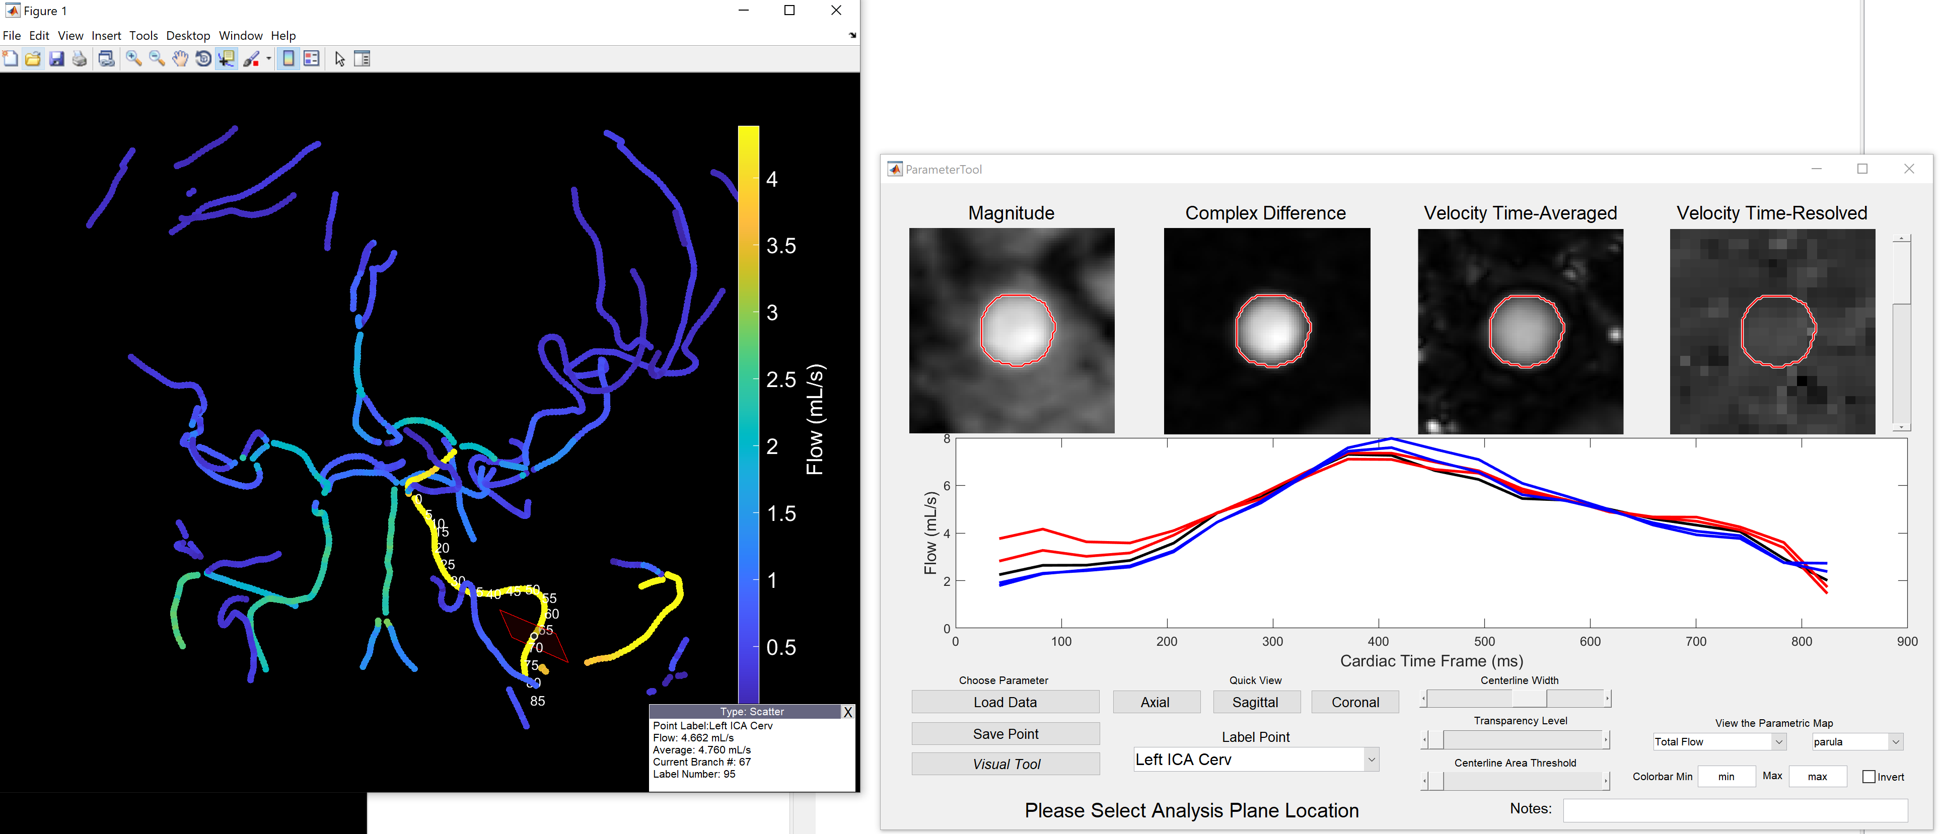

After selecting a landmark (e.g. cervical ICA ( red outlined plane)) you can see the flow profile along that vessel on the figure to the right. Notice you see 5 curves, which are the flow curves for the selected point and the next +2 and -2 points. You can verify data quality by inspecting the shape of the waveforms, noticed flow should be a smooth pulsatile curve ( a smooth systolic and diastolic phase) without extreme flow changes. If data looks of bad quality scroll thru the Velocity Time-Resolved images (top right) which might reveal bad time frames (e.g. aliasing = velocity wrapping).

Once satisfied with your measurement select the Label Point ( in this case Left ICA Cerv) and Save Point. If we check the summary spreadsheet we see our recorded data:

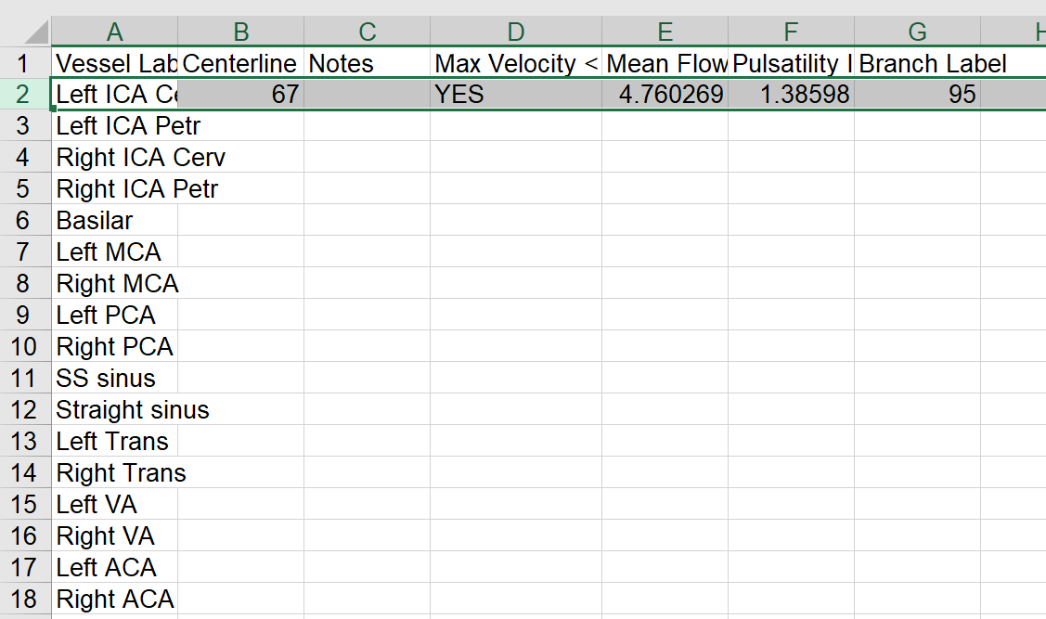

Summary sheet

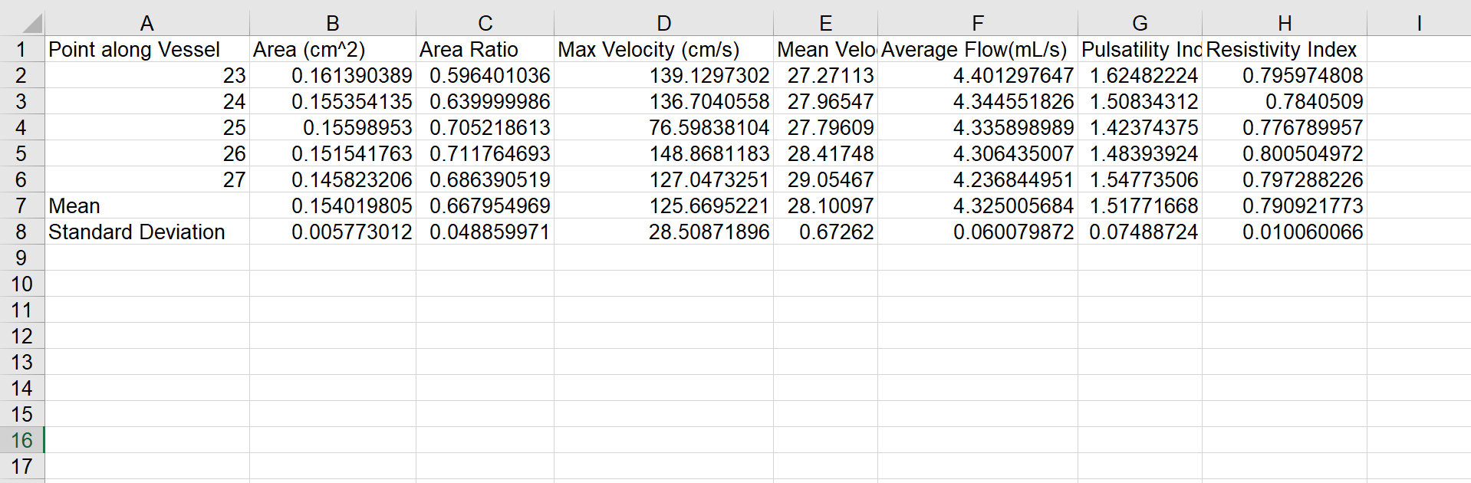

Time average sheet

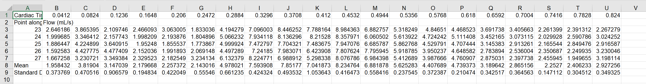

Time resolved sheet

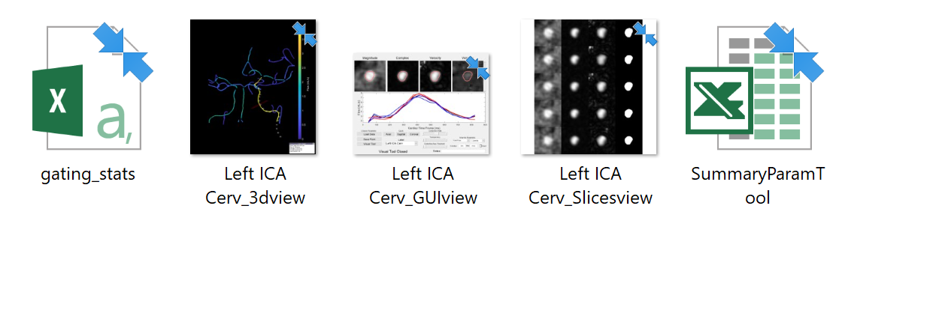

Automatically generated snapshots

When extracting measurements some vessels might be obfuscated or hard to “see” because of other vessels are on the way. To help you extract measures, make yourself familiar with the help tools showed on the GUI e.g. Centerline Width, Transparency Level, and Centerline Area Threshold. These tools just affect the visualization of the angiogram (not the measurements). You can also leave notes for the saved measurements, just enter them on the Notes: space (leaving notes is encouraged when in doubt or identifying potential concerns!!). Notice that the View the Parametric Map lets you change the variable and colormap of the displayed angiogram. Notice the Quick View options (Axial, Sagittal, Coronal) , clicking on them will automatically re-orient the angiogram to the selected view plane.

On the Choose Parameter options try selecting *Visual Tool.* It will open two additional windows:

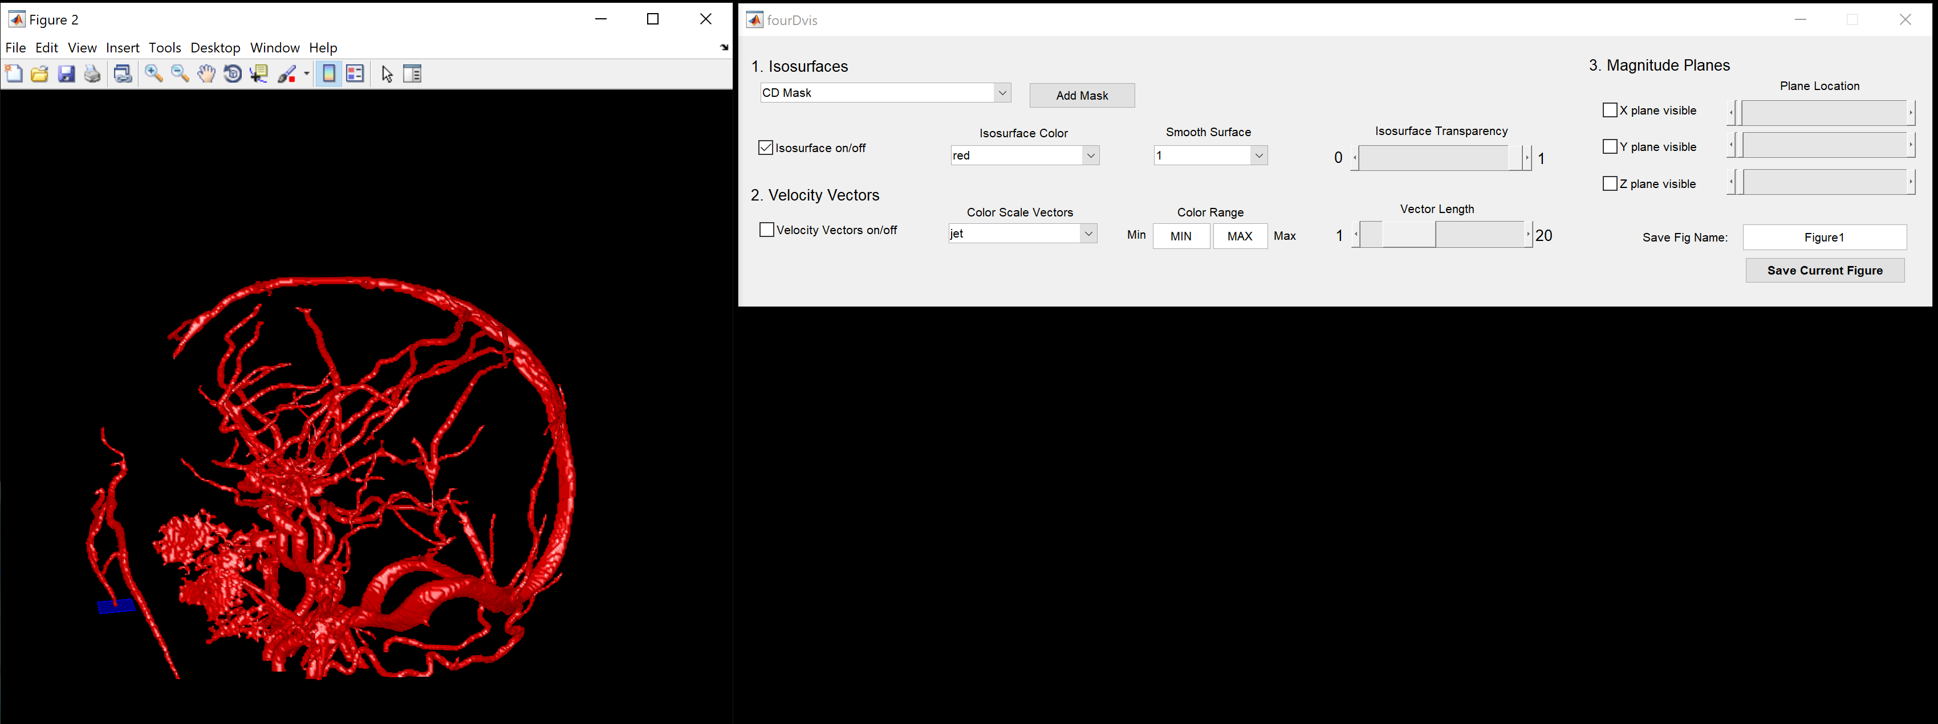

The visual tool was designed with the idea of generating images for presentations/papers etc. I suggest you try the many options and have some fun generating a few cool images!

***Where to performed flow measures?***

Small vessel measures are prone to noise, that is why we typically measure flow in larger vessels. Common vessel landmarks are shown below:



Arteries:

Notice the Cervical ICA (lower planes) and Petrous ICA (higher plane), and the posterior cerebral artery. These are both bilateral arteries.

Approximate measurement locations:

**Basilar Artery:** measure about 7 points from the bottom (roughly 5 mm from where it forms)

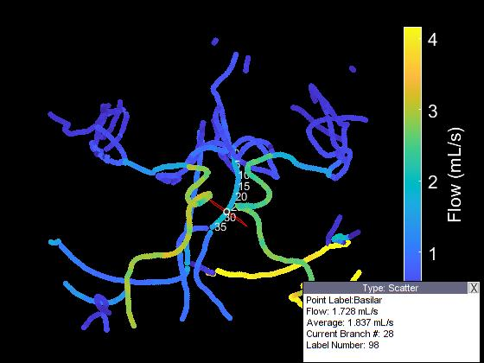

**ICA**: **Cervical (Inferior):** 10 down from end of straight part

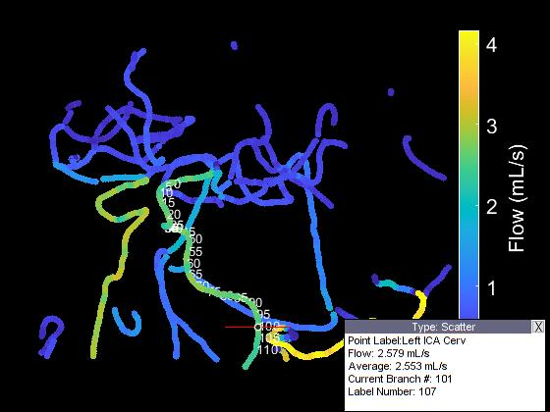

**Petrous (Superior):** 10 down from corkscrew

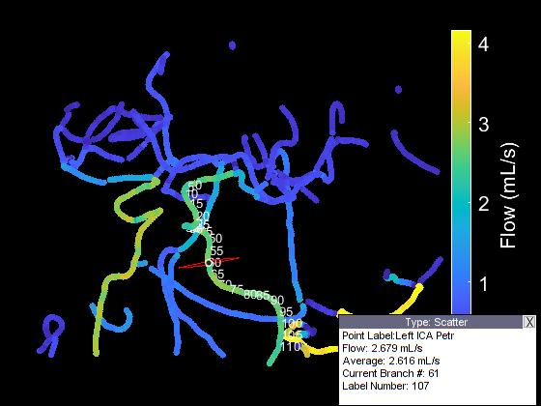

**MCA**: measure 7 points away from the split (from the higher numbers)

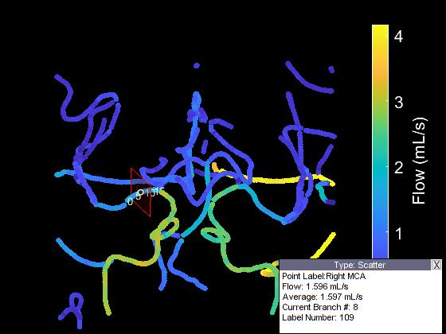

**PCA**: measure 10 points from when it starts to travel back (if PCA comes off ICA, note in GUI)

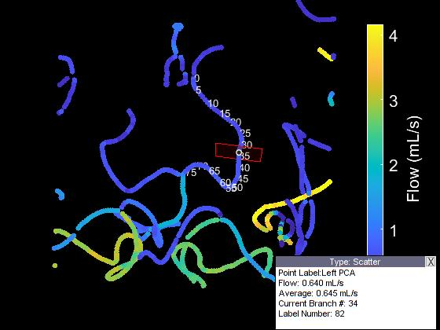

Veins:

Superior sagittal sinus, straight sinus and transverse sinus.

You might also want to include basilar artery (BA) and middle cerebral artery (MCA) measurements:

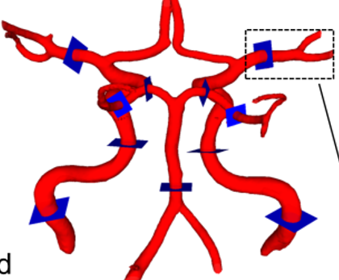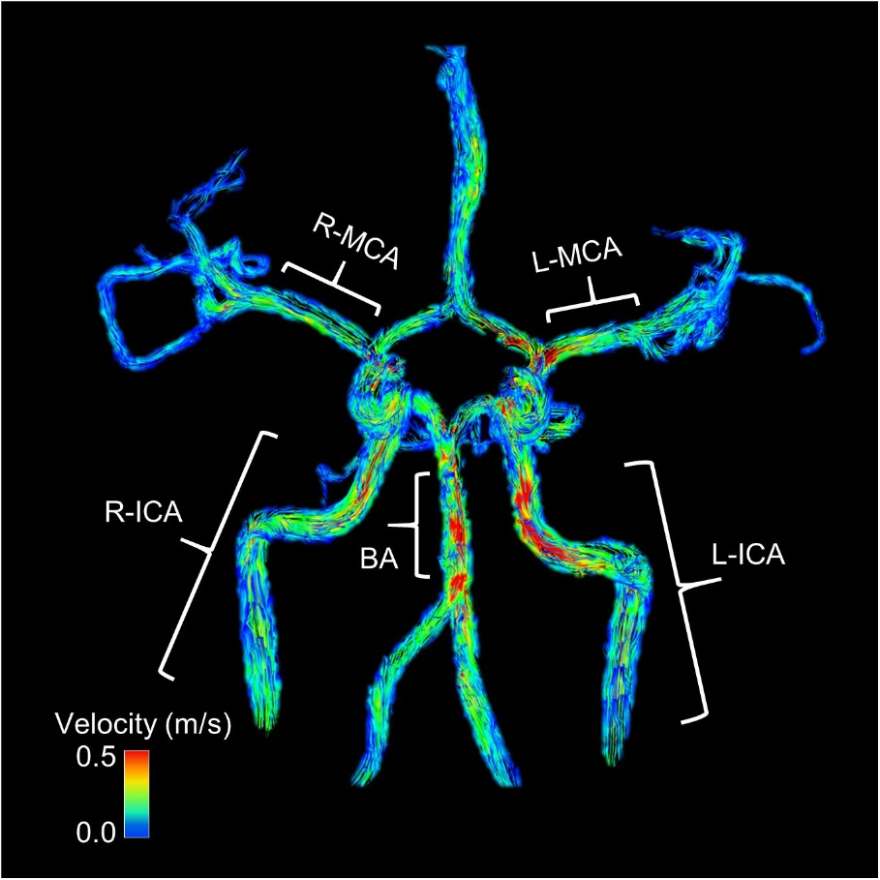

**Superior Sagittal Sinus (SS sinus):** measure 64 points from the bottom

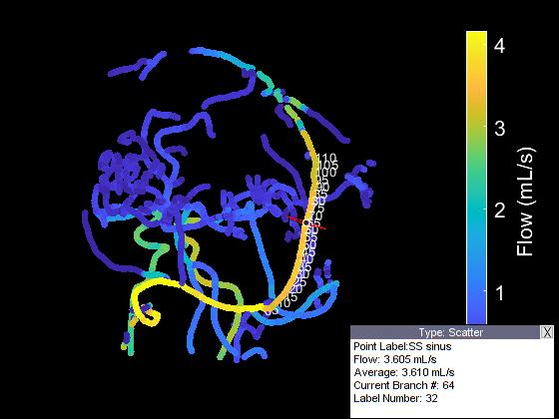

**Straight Sinus:** measure 20 points from where it forms

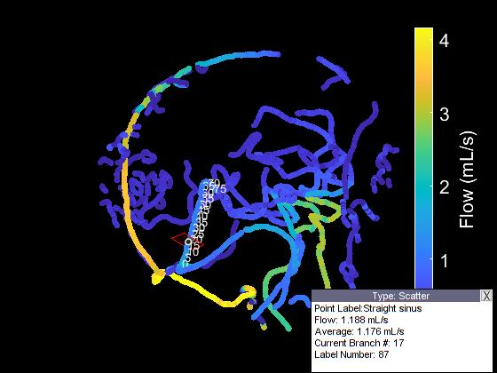

**Transverse Sinus**: measure roughly 36 points from where it forms. Dominant vs. Non-dominant?

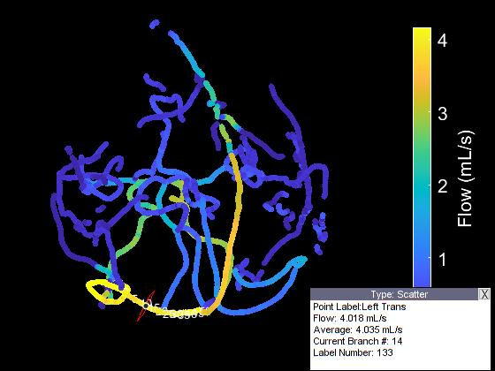

Here is similar set of criteria that Grant Roberts and Anthony Peret developed for their work in their normative cranial 4D flow study:

|  |  |  |
| --- | --- | --- |
| **Table 1**. Measurement locations (and ranges) for each vessel segment | | |
| **Vessel Segment** | **Abbreviation** | **Anatomical Landmark and Criteria\*** |
| Cervical ICA | ICA-C1 | C1 segment (1-10 centerline points from end of vertical portion) |
| Cavernous ICA | ICA-C3 | C3 segment (1-10 centerline points from start of vertical portion) |
| Middle Cerebral Artery | MCA | Middle M1 segment ± 5 centerline points |
| Anterior Cerebral Artery | ACA | Middle A1 segment ± 5 centerline points |
| Basilar Artery | BA | 10 ± 5 centerline points superior from BA-VA junction |
| Vertebral Artery | VA | 10 ± 5 centerline points inferior from BA-VA junction |
| Posterior Cerebral Artery | PCA | 5-10 centerline points before P2-P3 junction |
| Superior Sagittal Sinus | SSS | 15 ± 5 centerline points from confluence of sinuses |
| Straight Sinus | STR | 15 ± 5 centerline points from confluence of sinuses |
| Transverse Sinus | TS | 15 ± 5 centerline points from confluence of sinuses |
| *Criteria were determined based on discrete centerline points along each identified vessel segment. | | |